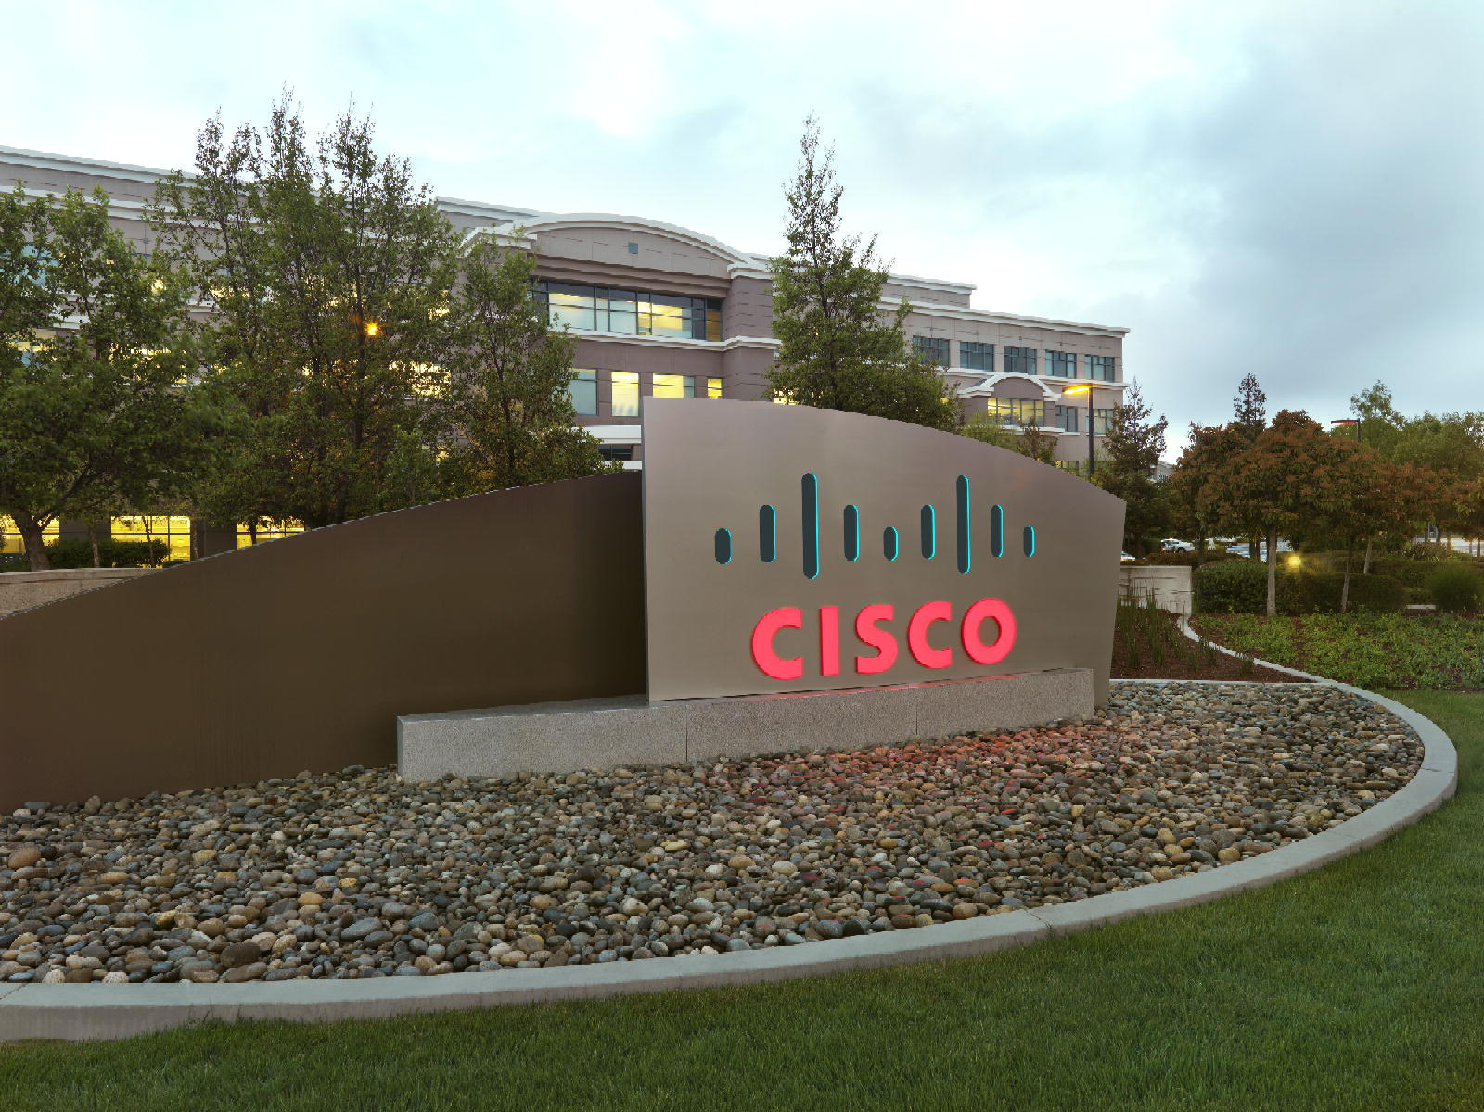

Advanced Services Assets
Field Developed Utilities - Developer's Guide
Data Virtualization Business Unit Advanced Services
June 2014

TABLE OF CONTENTS
INTRODUCTION 4
Purpose 4
The purpose of this document is to provide guidance on how to extend the functionality of the Composite PS Promotion and Deployment Tool (“PD Tool”). 4
This document covers the following topics: 4
Audience 4
Advanced Services (AS) Assets Utilities Overview 5
What are the AS Assets Utilities? 5
Recommended Development Tools 5
GitHub Repository Structure 6
How Can I Download a Copy of the Utilities GitHub Repository? 6
Repository Folder Structure 6
DocumentationSource 6
DVSource 6
DVSource/cis_objects 6
DVSource/scripts 6
JavaSource 6
JavaSource/lib 6
Release 7
Release/archive 7
Configuring the AS Utilities Development Environment 8
Checking Out the AS Utilities DV Source Code 8
Checking Out the AS Utilities CJP (Java) Source Code 8
Clone the AS Utilities Git repository to your local machine 8
Create a Java project from the Git repository 12
Build the AS Utilities jar files 15

Document Control

Version History
Version | Date | Author | Description
1.0 | 06/22/2014 | Calvin Goodrich | Initial revision

Related Documents
Document | Date | Author
How To Use DVBU AS Utilities.doc | Q2 2014 | Calvin Goodrich

Data Virtualization Business Unit (DVBU) Products Referenced
DVBU Product Name | Version
Cisco Information Server | 6.2.6

INTRODUCTION

Purpose
The purpose of this document is to provide guidance on how to extend the functionality of the Composite PS Promotion and Deployment Tool (“PD Tool”).

This document covers the following topics:
- Advanced Services (AS) Assets Utilities Overview - Describes the history and use of the AS Assets Utilities distribution.

- Extending and/or Contributing to the AS Assets Utilities distribution.

Audience
This document is intended to provide guidance for the following users:
- Composite Information Server (CIS) Developers

Advanced Services (AS) Assets Utilities Overview

What are the AS Assets Utilities?
The AS Assets Utilities, or simply "The Utilities", were started as an internal project to collect the ever increasing number of simple SQL Scripts and custom Java procedures (CJPs) that ended up being reusable at multiple customer sites. Rather than reinvent the wheel at each customer, it was proposed that these simple procedures should be gathered and made available to all customers free of charge (since nearly all these procedures were developed at one customer site or another on billable engagements) and with the understanding that they were supported by the then Composite Software field personnel and that the IP for these Utilities were owned by Composite Software.
The Utilities are made up of a number of procedures that perform relatively simple tasks, such as string, date/time, and XML manipulation; interactions with the CIS repository or CIS host filesystem; and helpers for working with another AS Asset known as "PDTool".
These procedures are not intended to be full custom solutions (though many end up being used in such solutions) but are simple timesavers that make the life of a CIS developer easier.
With the acquisition of Composite Software by Cisco Information Systems, Inc. it was decided that support by the now Cisco DVBU field personnel was no longer a viable support model for the Utilities and that they should be opened up to the customer base as an open source project.

Recommended Development Tools
CIS itself can (and should) be used for developing the SQL Script procedures. Any robust Java IDE can be used to develop the CJPs, however up to this point, the CJP's have been developed using Eclipse. The CJP artifacts in the open source repository (GitHub) are therefore geared towards an Eclipse project.
Git is used as the version control system for the Utilities open source project. For those new to Git, a visit to https://help.github.com/articles/set-up-git will provide an overview of Git and instructions on downloading and setting up the basic Git tools.
GitHub Repository Structure

How Can I Download a Copy of the Utilities GitHub Repository?
The GitHub master repository for the Utilities is located at https://github.com/cisco/ASAssets_Utilities. Cisco employees should contact Michael DeAngelo in the Data Virtualization Business Unit (DVBU) for access to the Cisco internal branch of the Utilities, "dvbu-test/ASAssets_Utilities".

Repository Folder Structure
The folder structure of the GitHub repository contains CIS source, custom Java source, documentation source, and distribution resources.

DocumentationSource
This folder contains the source versions of the user's guide and developer's guide (this document) in Microsoft Word format. When a release version of a document is ready for distribution, it should be saved in PDF format and placed in the Release folder.

DVSource
This folder contains the source code for the Utilities DV resources.

DVSource/cis_objects
This folder contains the exported CIS resources in the version control export format. Instead of a single .CAR file, the resources are exported in a folder tree structure that matches the container structure in CIS. A .CMF file named for the resource with a resource type suffix contains the resource's source code, model, ownership information, annotation, permissions, etc. A container will have a corresponding .CMF file contained inside it.

DVSource/scripts
This folder will contain (still in development) a number of Windows batch files and Linux shell scripts that can be used to import the resources in the cis_objects folder into a CIS instance and export resources from a CIS instance into the cis_objects folder structure. An update to the PDToolStudio distribution to support Git is on the road map.

JavaSource
This folder contains the source code for the Utilities DV resources. It contains an Eclipse project that can be used to build individual CJP data source jars or all of them in one build. Each CJP collection has a child folder here.

JavaSource/lib
This folder contains library jar files used to build the CJP jars. Open source libraries have corresponding LICENSE.txt files. CIS libraries are named with a "cs" prefix.

Release
This folder contains the current release of the Utilities and corresponding documentation.

Release/archive
This folder contains past releases of the Utilities and corresponding documentation.

Configuring the AS Utilities Development Environment

Checking Out the AS Utilities DV Source Code
TBD. For now, the best way to make sure a new or updated SQL Script gets into the next release is to send the script (plus documentation and examples!) in a CAR file to Calvin Goodrich.

Checking Out the AS Utilities CJP (Java) Source Code
CJPs for the AS Utilities are currently developed in Eclipse. These instructions are based on the Luna distribution of Eclipse (if not using this release then the following steps may need to be modified. For instance, Luna includes the Git client, whereas earlier releases of Eclipse do not.) If installing Eclipse for the first time, the "Eclipse Standard" (or "Eclipse IDE for Java Developers", if space is tight) should be used.

Clone the AS Utilities Git repository to your local machine
For the next steps, start Eclipse and make sure to apply any updates (Help -> Check for Updates).
- Open the Git perspective using the "Open Perspective" panel in the upper right of the Eclipse screen:
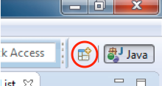
- Choose the Git perspective:
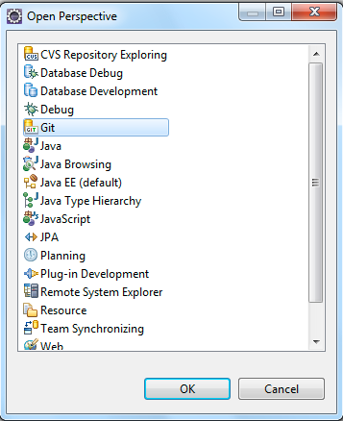
- In the "Git Repositories" panel, click the "Clone a Git repository" link. Alternatively, go to the "File" menu and select "New"->"Other…" Choose "Git"->"Git Repository" from the resulting dialog.
- In the resulting dialog, paste the Git repository URL https://github.com/cisco/ASAssets_Utilities.git into the "URI" field. Cisco employees should use the https://github.com/dvbu-test/ASAssets_Utilities.git URL. The "Host" and "Repository Path" fields should auto-populate. Enter your Git user name and password and click "Next >".
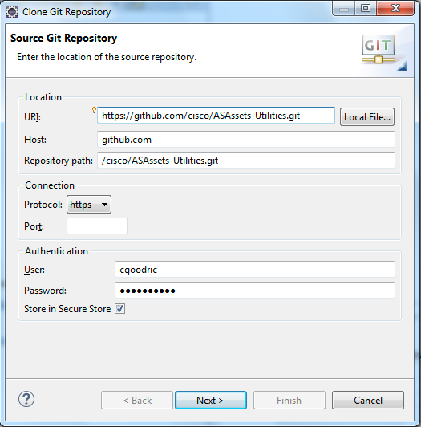
- The "Branch Selection" screen should show one branch called "master". This should already be selected so click "Next >".
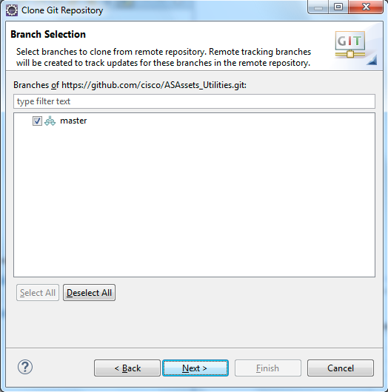
- Choose the location where the downloaded source code should be stored. Click "Finish".
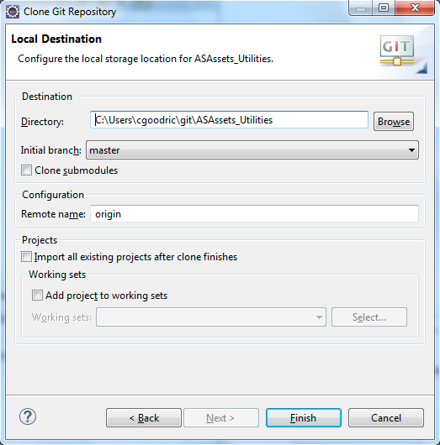
- A progress dialog will appear indicating how far along the clone process is. Once done, the ASAssets_Utilities clone should then appear in your Git Repositories list.
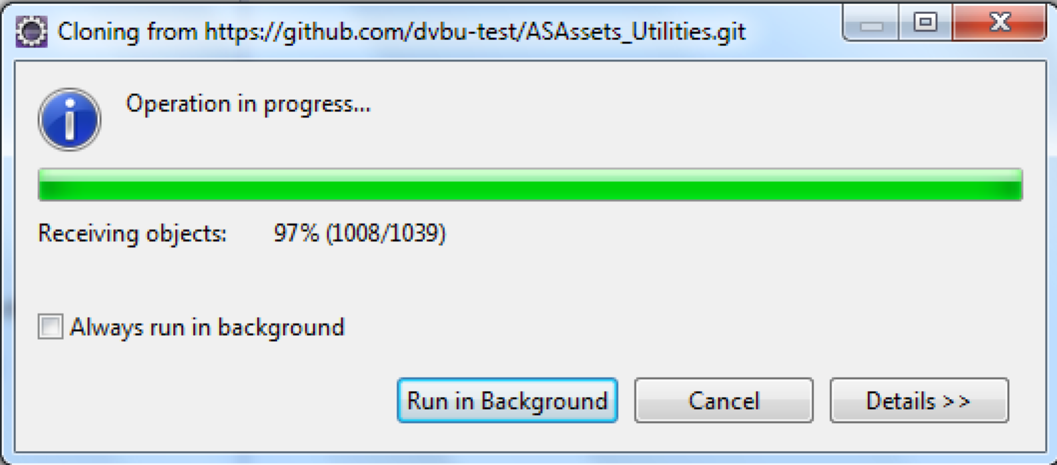

- You may get an error stating that your secure store password has not been set. This can be safely ignored but it's probably a good idea to go into the Eclipse preferences and set a password for your secure storage.
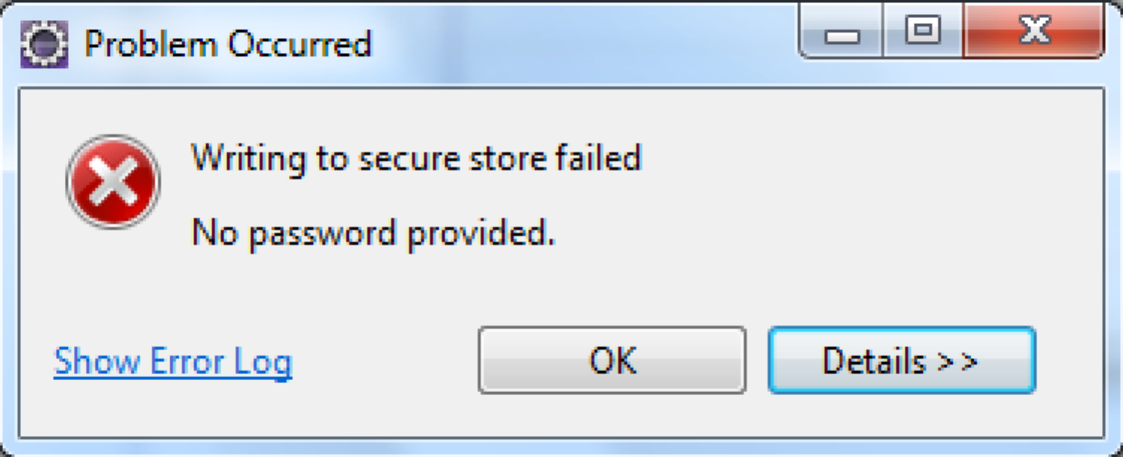

Create a Java project from the Git repository
- Open the Java perspective clicking the "Java" perspective button in the upper right of the Eclipse screen.
- Right-click in the "Package Explorer" panel on the left side of Eclipse. Select "Import …"
- Drill into "Git" and select "Projects from Git". Click "Next >".
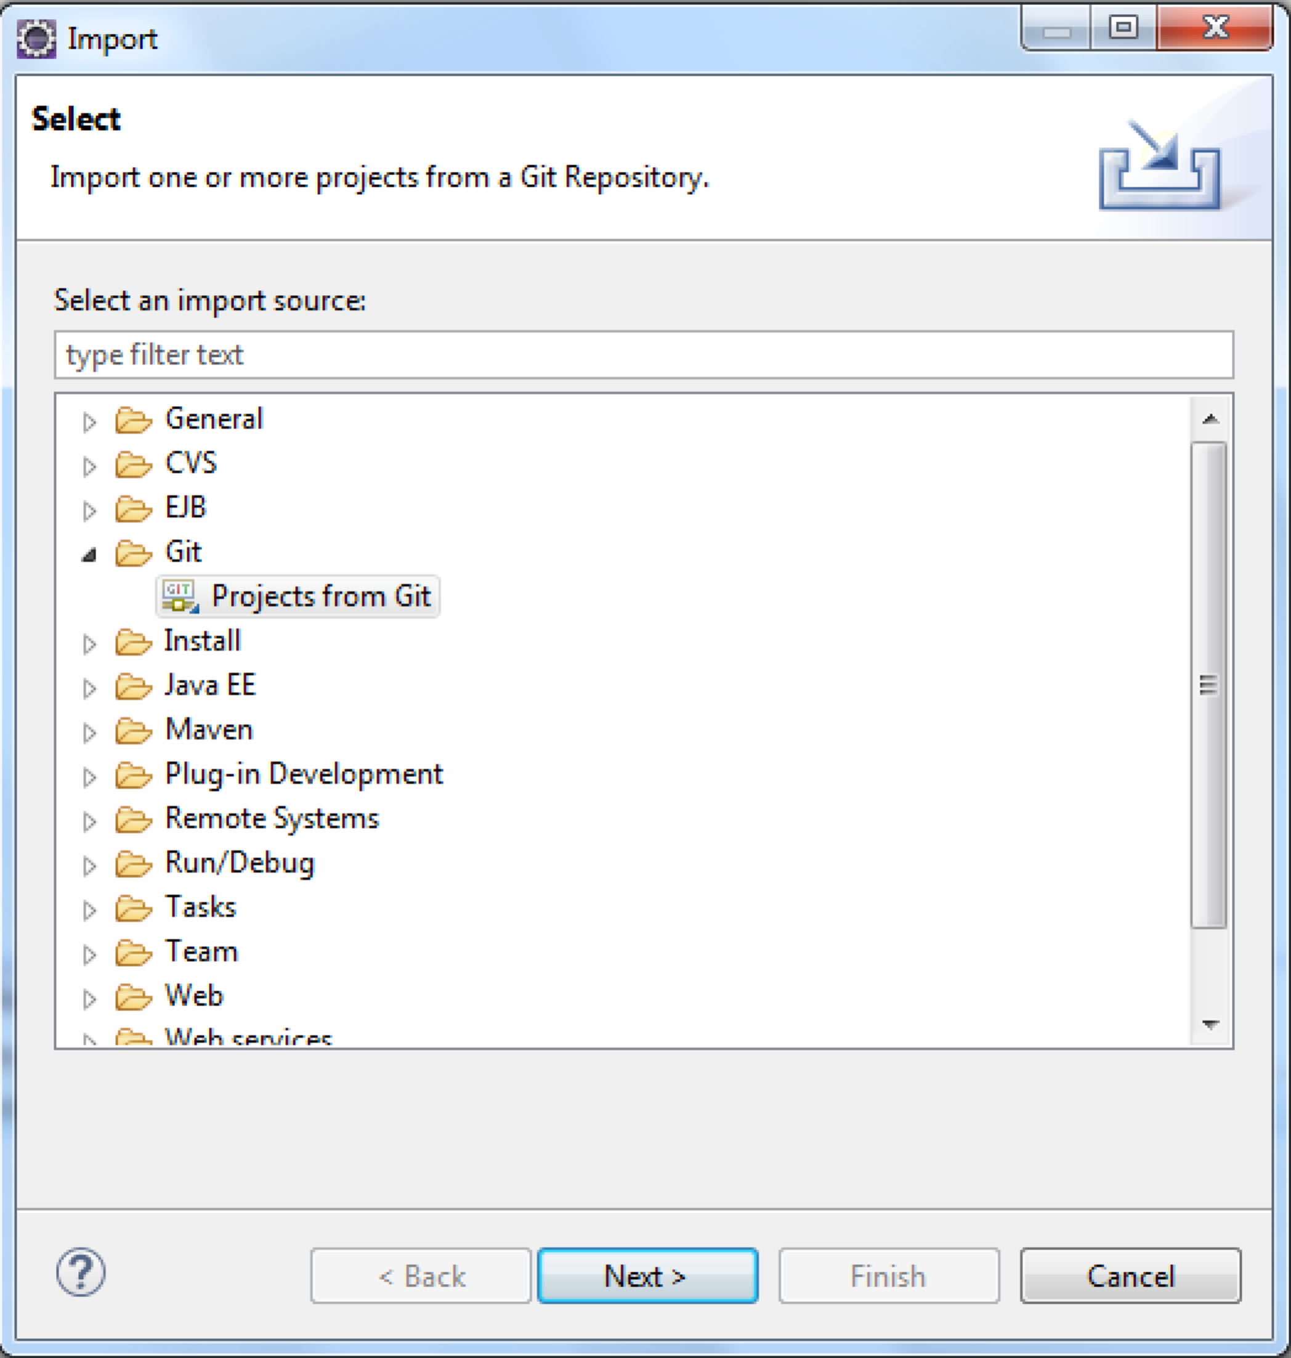
- In the next panel choose "Existing local repository". Click "Next >".
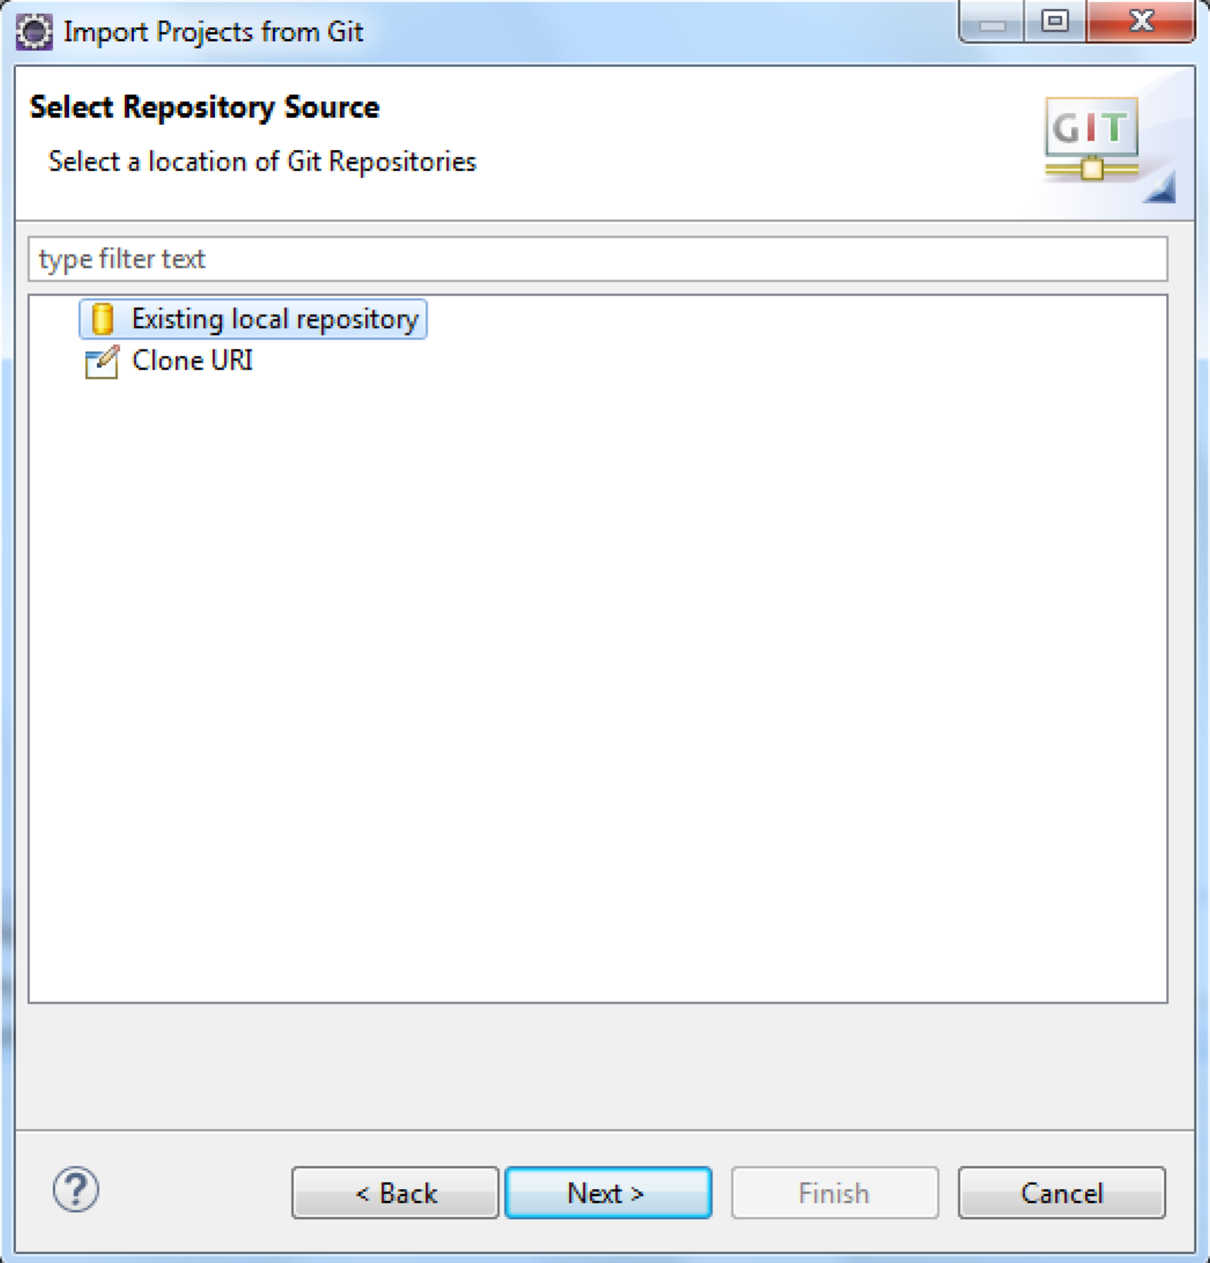
- Choose the "ASAssets_Utilities" repository. Click "Next >".
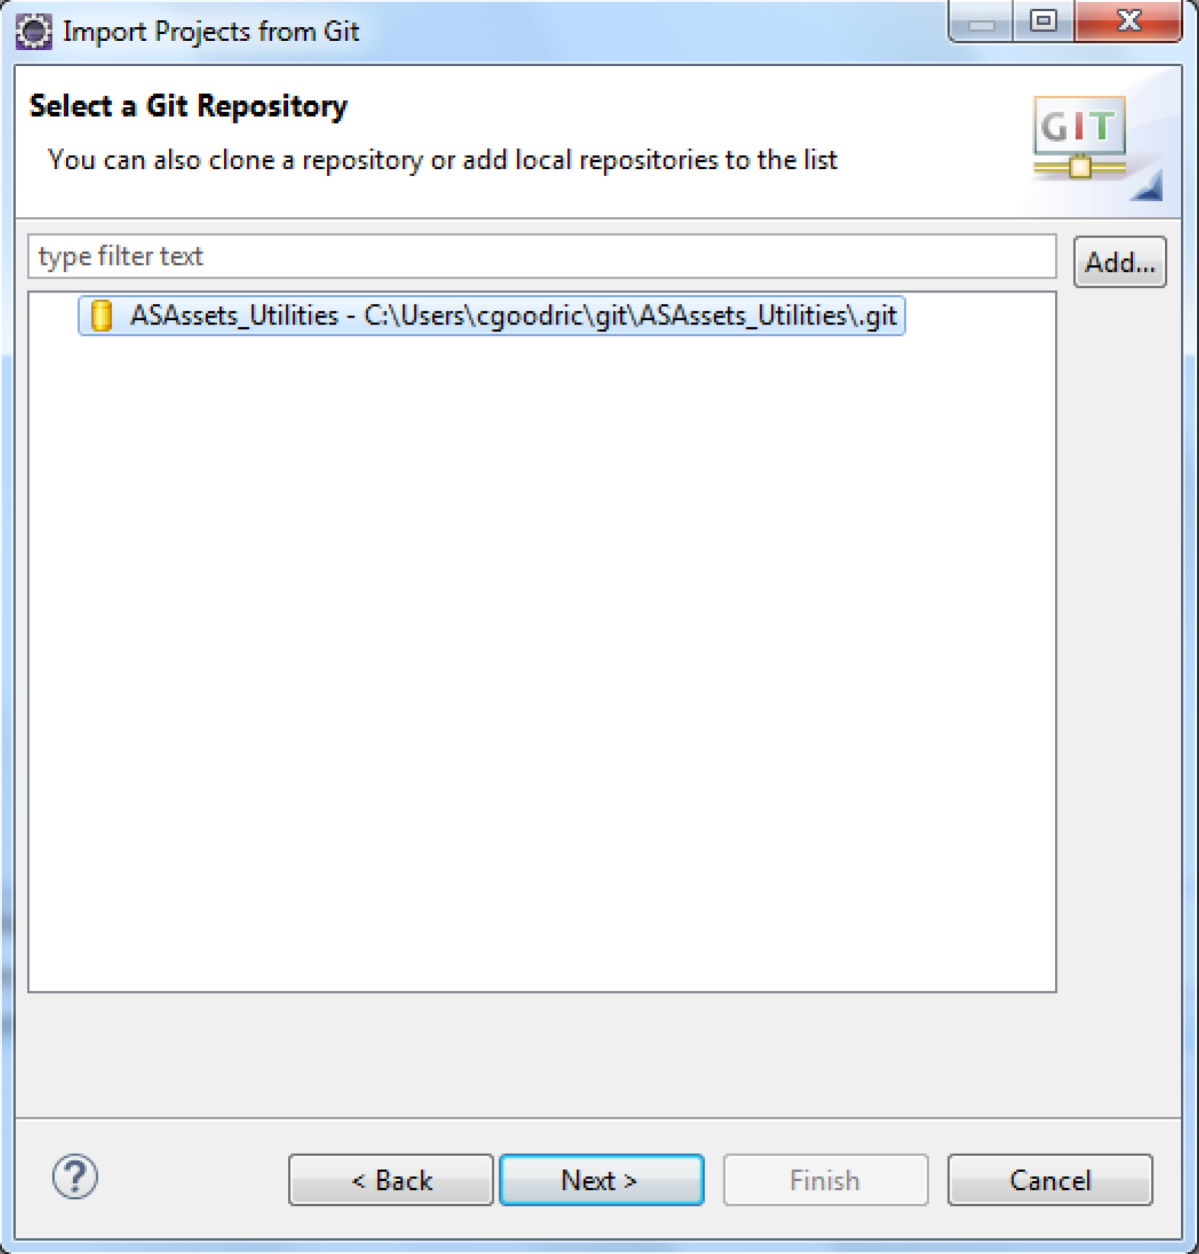
- Select "JavaSource" as the root folder to import. Click "Next >".
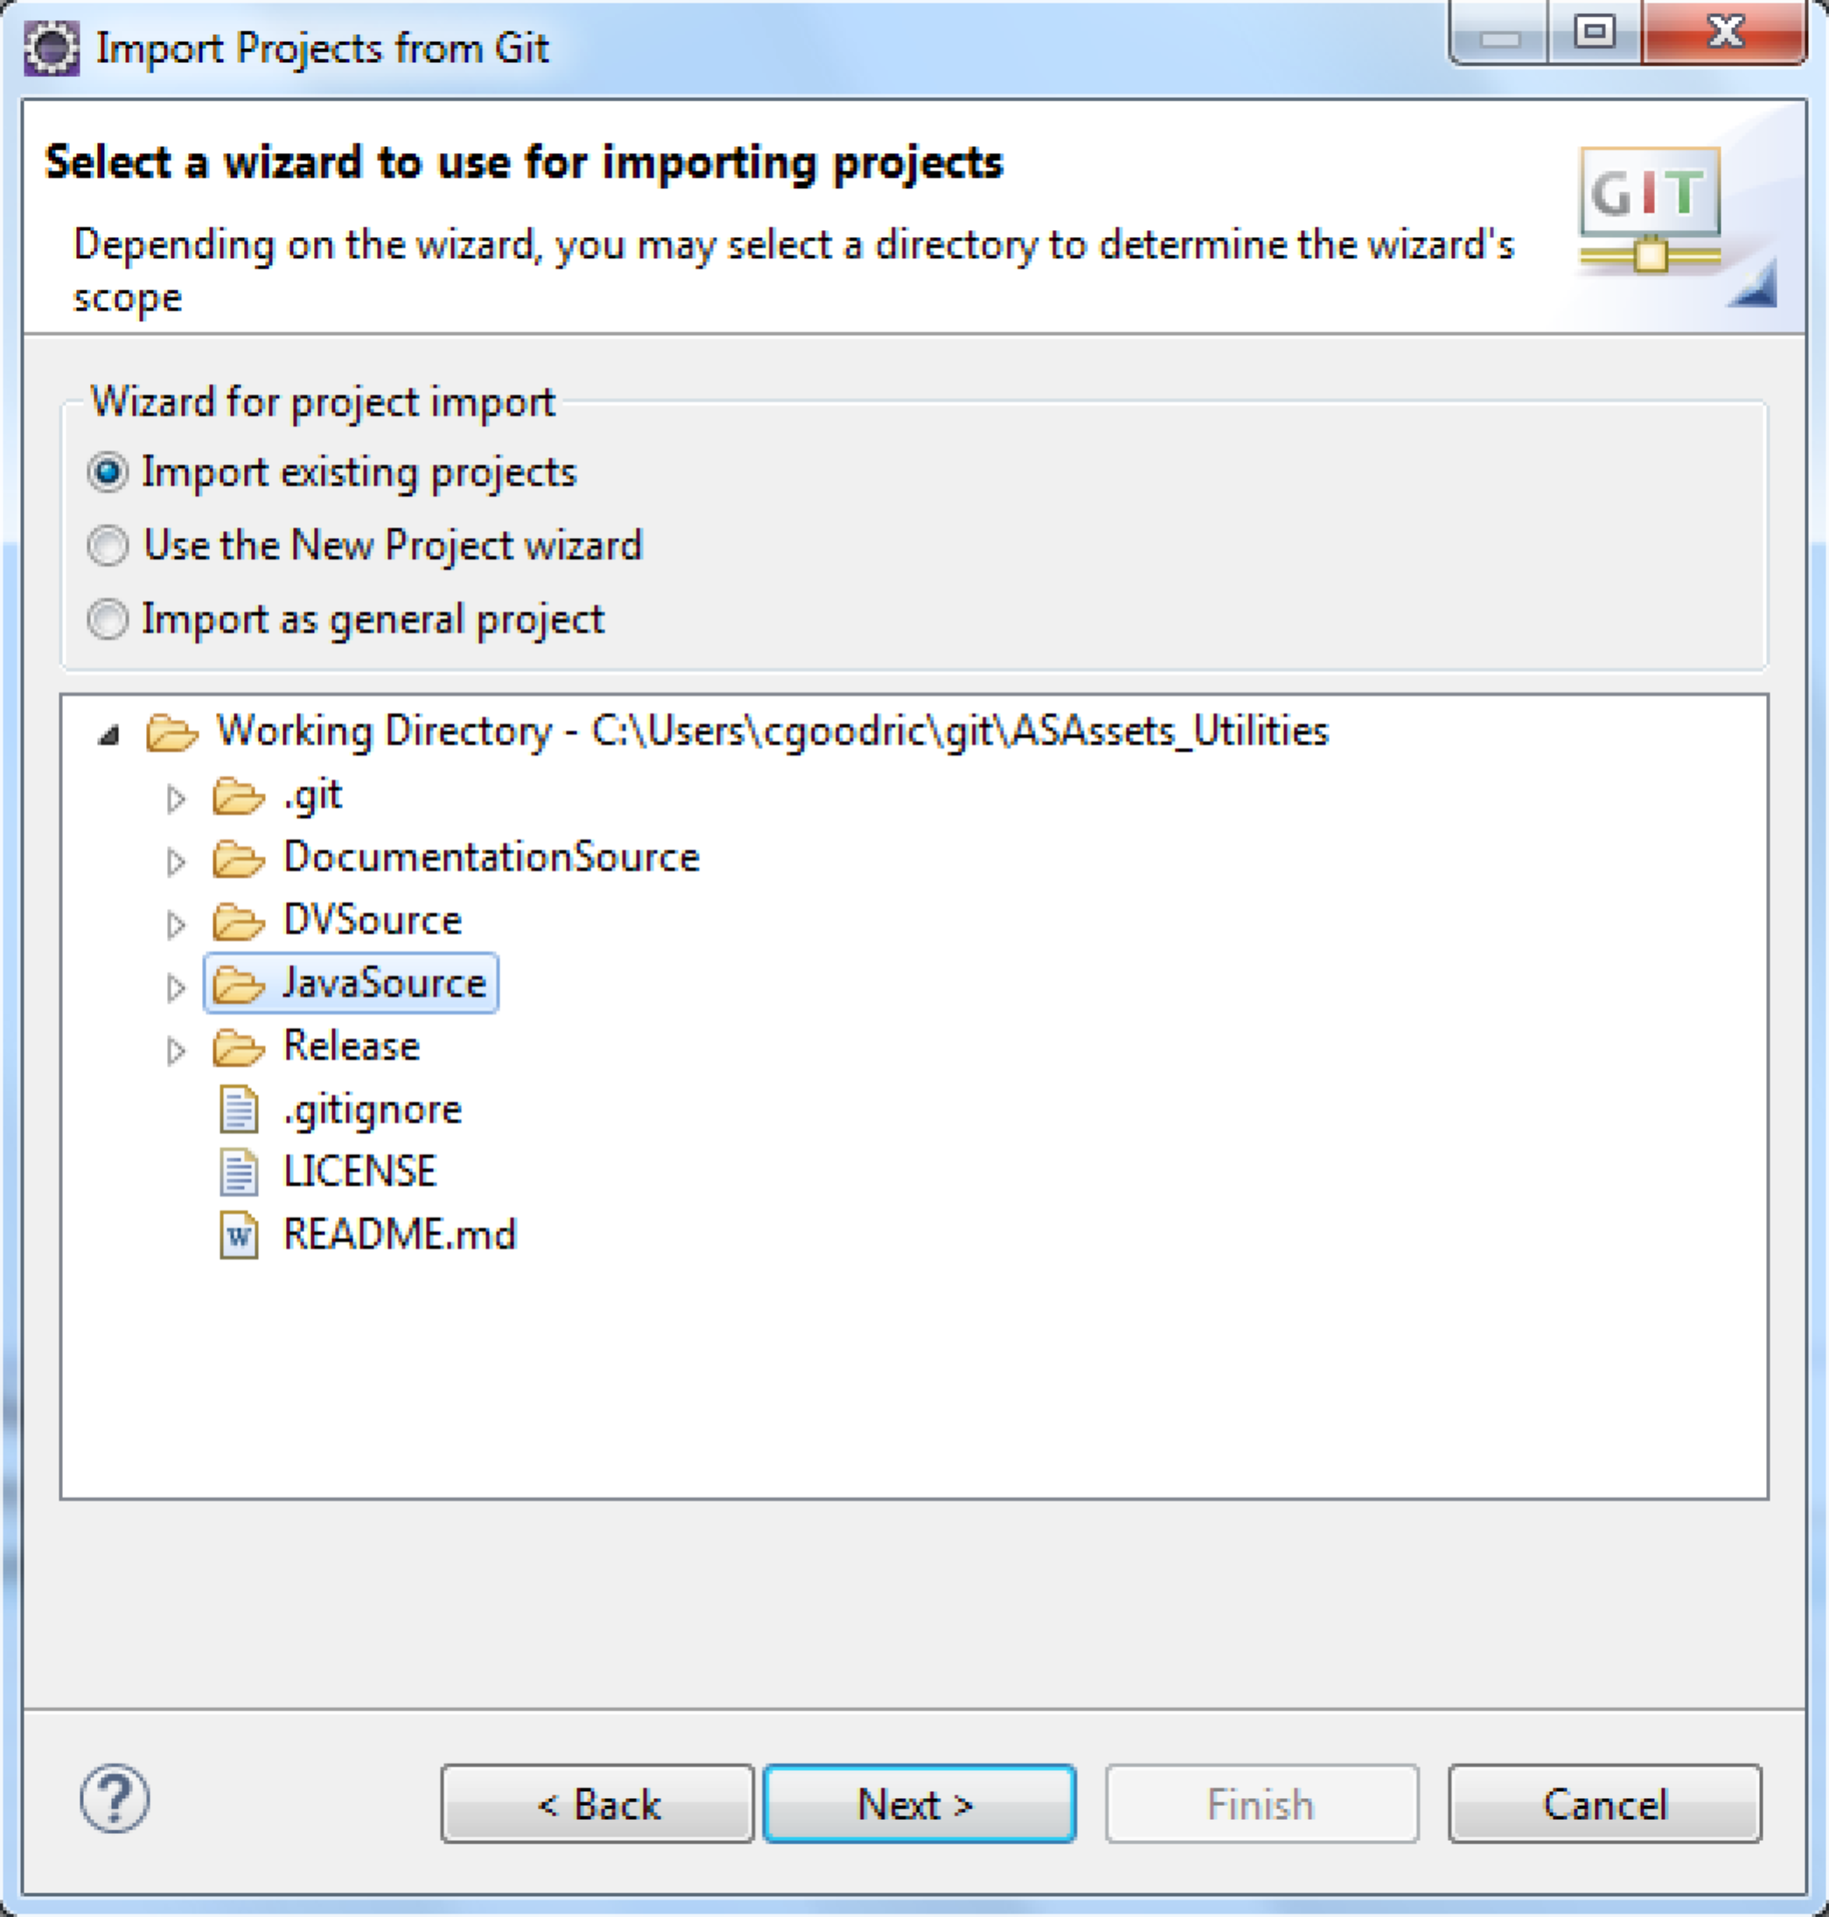
- There should only be one project to import. Click "Finish".
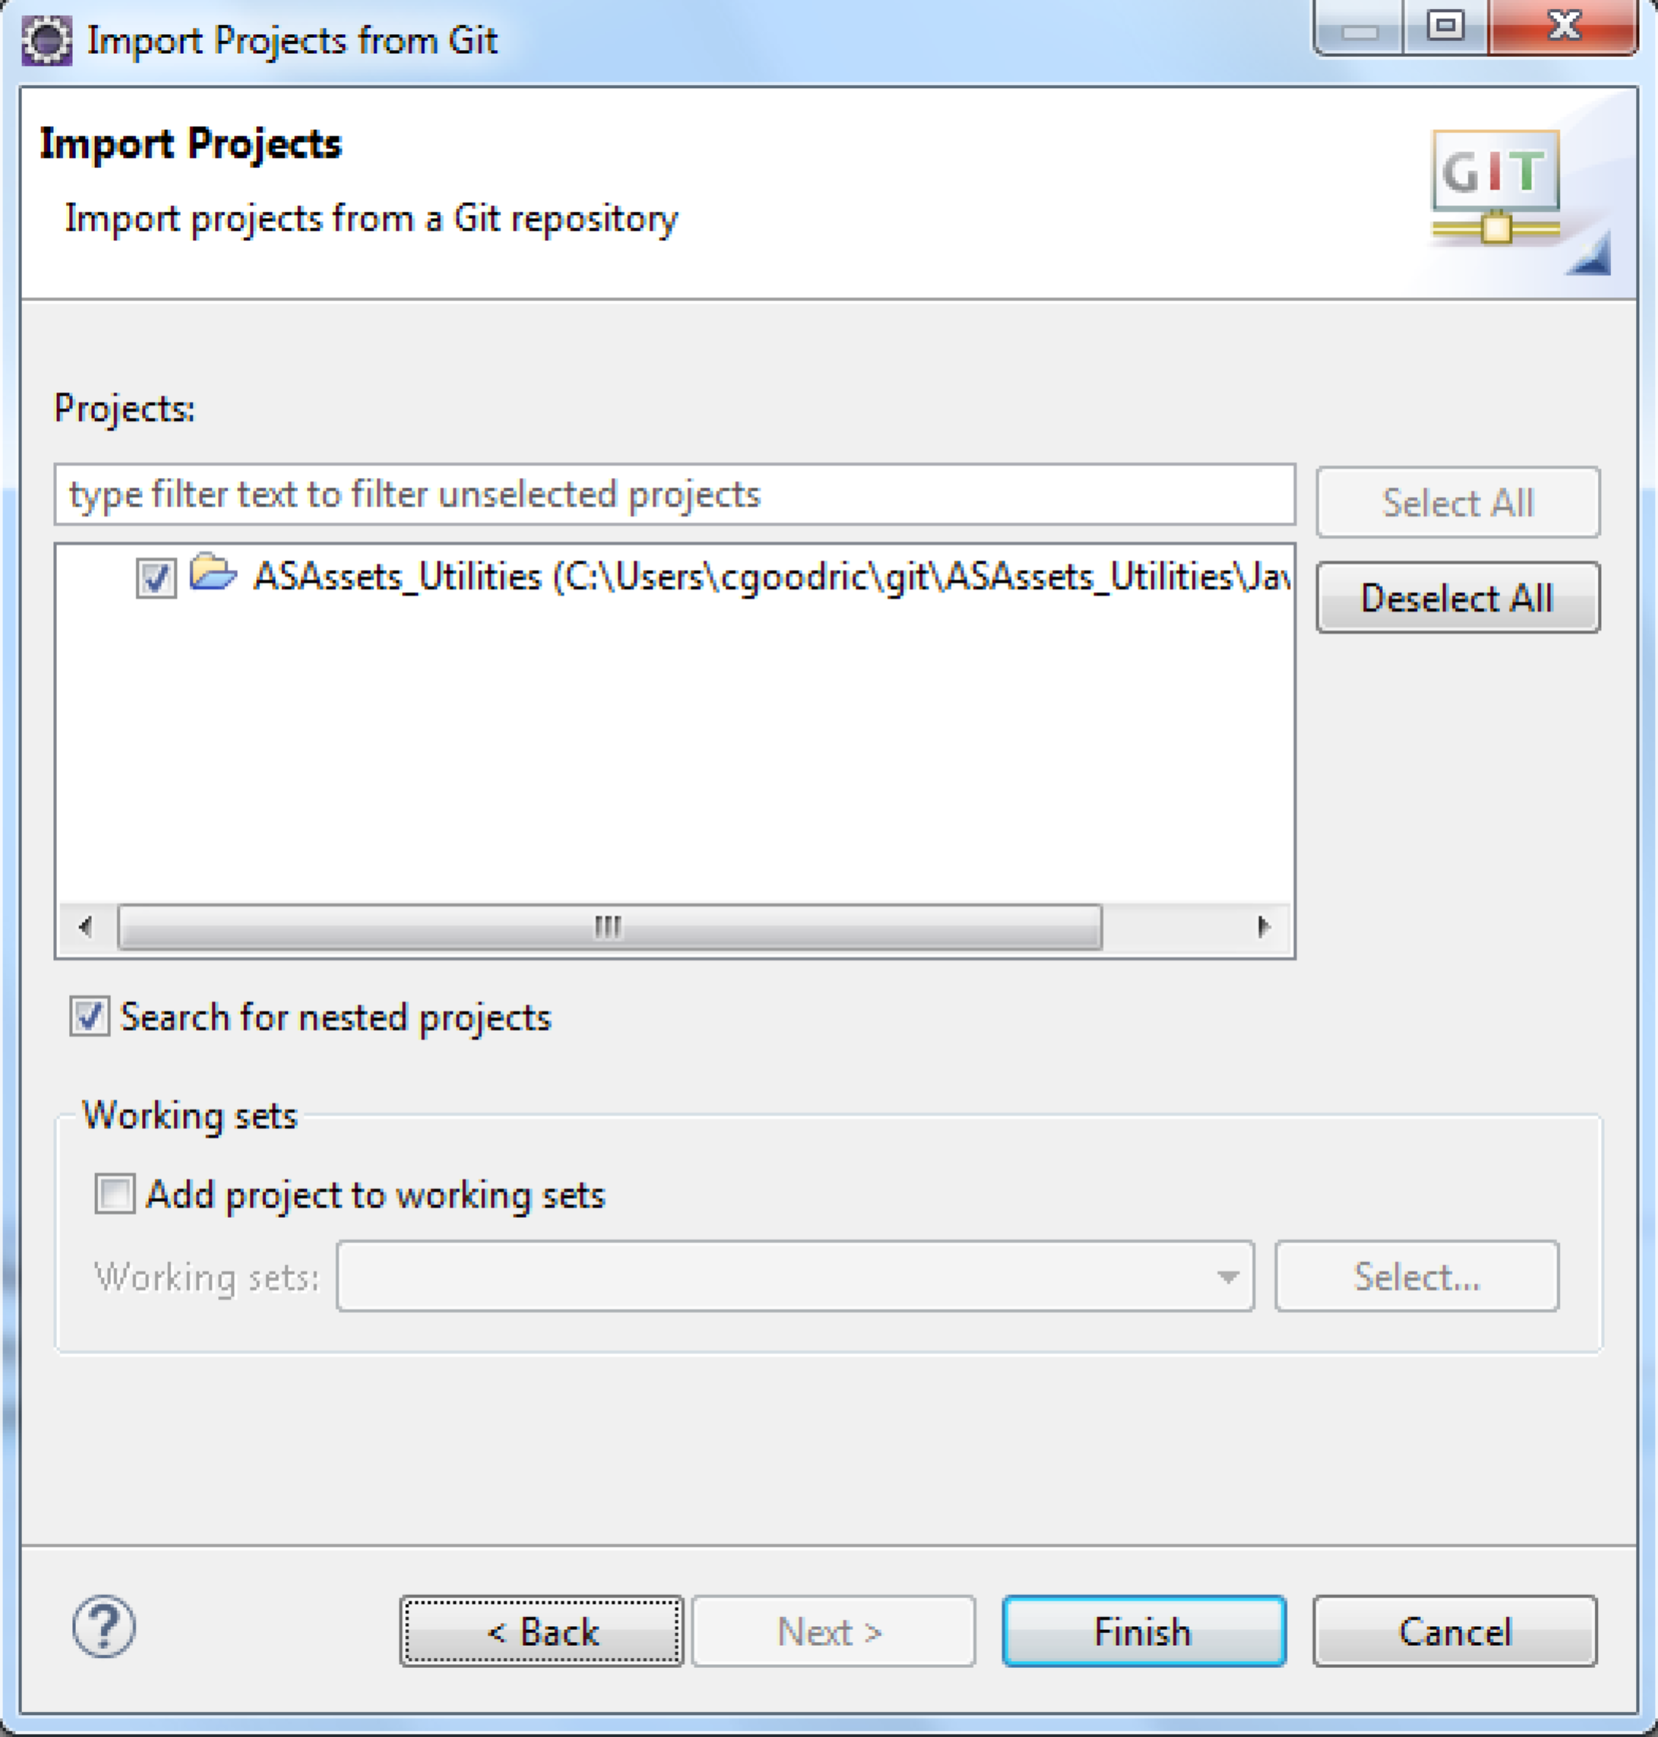
- The imported project:
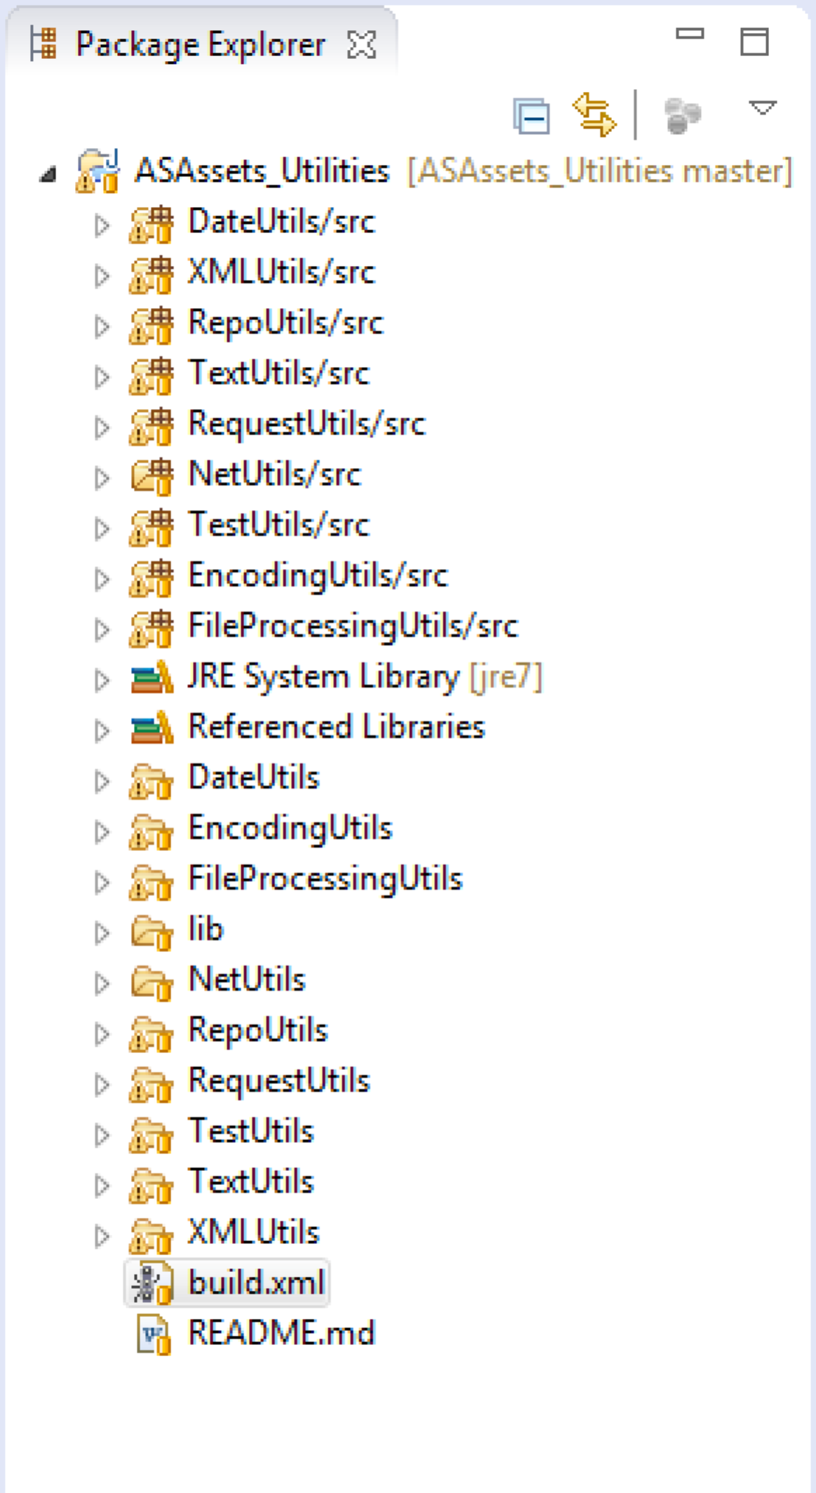

Build the AS Utilities jar files
Building the jar files for the CJP data sources is very straightforward. Each CJP folder contains a "build.xml" file that can be used to build jar files individually. Alternatively, the "build.xml" file in the project's root folder can be used to build all the jar files in one build. When one or more jar files are built, they will appear in the "dist" folder in the project's root folder.


Printed in USA CXX-XXXXXX-XX 10/11

